MYSQL to PowerBI:


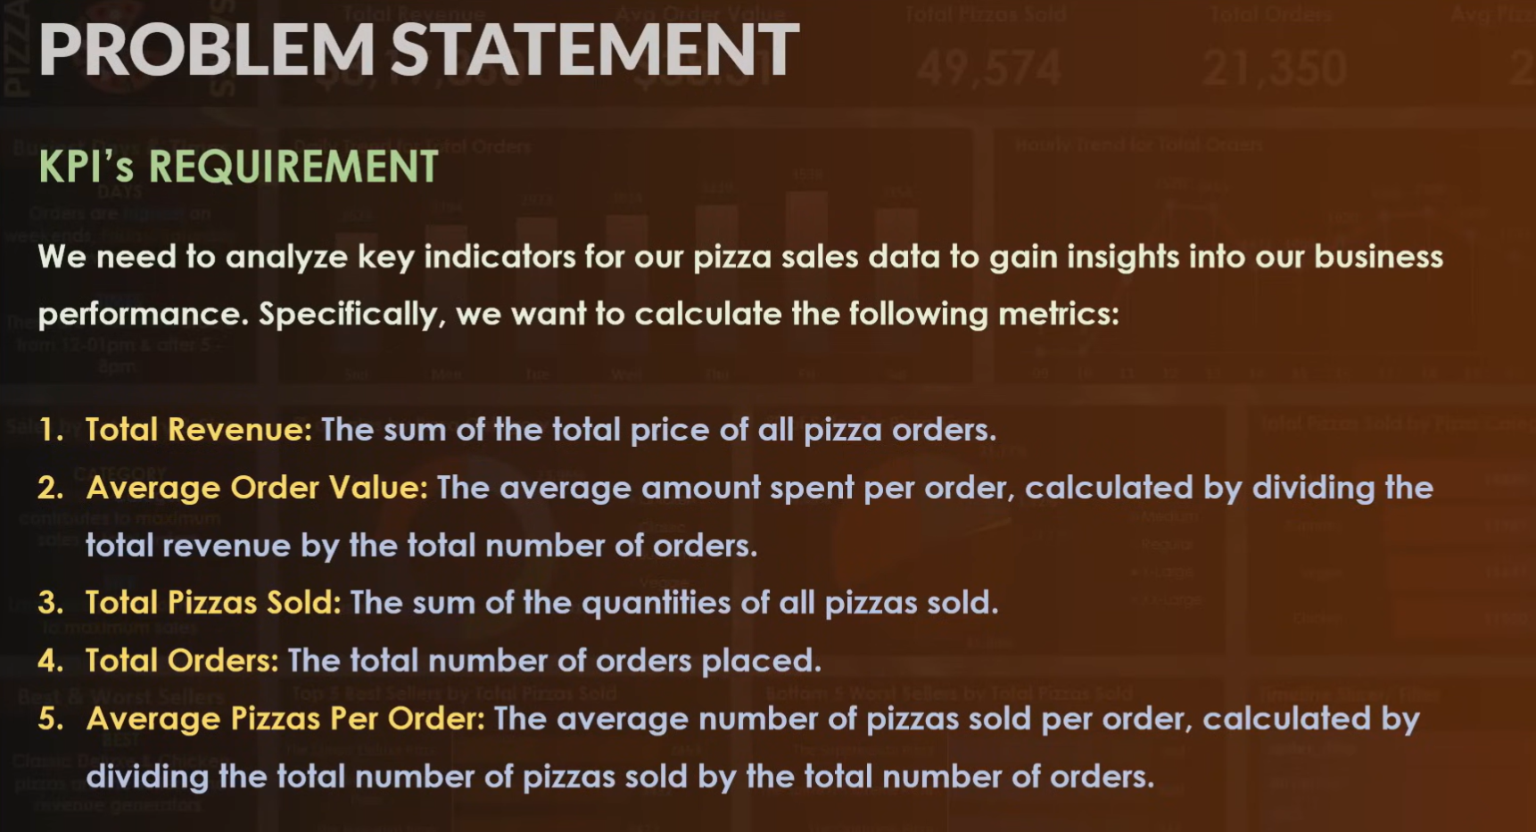

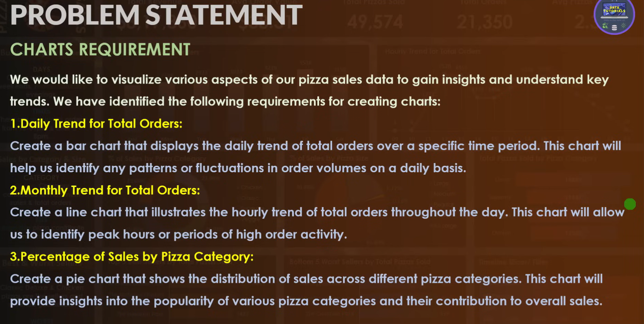

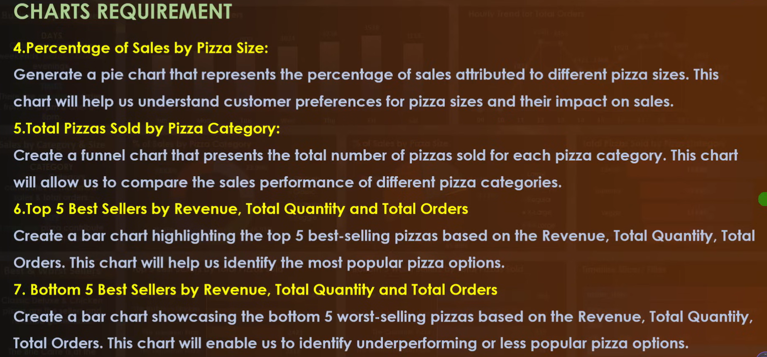

DataBase:
create database pizza_db;
use pizza_db;
Tables:
show tables;
select * from pizza_sales;
Reqirement:
-- Total Revenue----
select sum((quantity * unit_price)) as TotalRevenue from pizza_sales;
select sum(total_price) as TotalRevenue from pizza_sales;

-- Averege Order Values--
select (sum(total_price) /count(distinct order_id)) as AverageOrderValues from pizza_sales;

-- Total Pizzas Sold-----

select (sum(quantity)) as TotalPizzaSold from pizza_sales;

-- Total Orders---

select sum(distinct order_id) as TotalOrders from pizza_sales;

-- Average pizza per Order----

select (sum(quantity)/count(distinct order_id)) as AveragePizzaPerOrder from pizza_sales;

-- Daily Trend for Total Orders -----

select distinct(order_date) as DailyOrderDate ,count( distinct order_id) as TotalOrders from pizza_sales group by order_date;

-- Monthly Trends for Total Orders------

SELECT DATE_FORMAT(STR_TO_DATE(order_date, '%d-%m-%Y'), '%M') AS MonthName, count(distinct order_id) as TotalOrders
FROM pizza_sales group by DATE_FORMAT(STR_TO_DATE(order_date, '%d-%m-%Y'), '%M');
-- Percentage of Sales by pizza_category
SELECT
pizza_category,
SUM(total_price) AS CategorySales,
(SUM(total_price) / (SELECT SUM(total_price) FROM pizza_sales)) * 100 AS Category_Percentage
FROM pizza_sales
GROUP BY pizza_category;

select pizza_category,sum(total_price) as CategorySales,(sum(total_price)/ (select sum(total_price) from pizza_sales) *100) as PercentageSales from pizza_sales group by pizza_category;

-- percentage of sales by pizza_size

select pizza_size,sum(total_price) as pizza_size_sales,sum(total_price)/(select sum(total_price) from pizza_sales) * 100 as PercentageOfSales from pizza_sales group by pizza_size;

-- Total pizza sold by pizza category

select pizza_category,sum(quantity) as TotalPizzaSold from pizza_sales group by pizza_category;

-- Top 5 Best seller by Revenue,Total Quantity and Total orders

select pizza_name,sum(total_price) as Revenue, sum(quantity) as TotalQuantity , sum(distinct order_id) as TotalOrders from pizza_sales group by pizza_name order by pizza_name desc limit 5;

-- Bottom 5 Best seller by Revenue,Total Quantity and Total orders

select pizza_name, sum(total_price) as Revenue, sum(quantity) as TotalQuantity,sum(distinct order_id) as TotalOrders from pizza_sales group by pizza_name order by pizza_name asc limit 5;

